# Hands-on Lab : Basics of PowerPoint

Estimated time needed: 15 minutes

Microsoft PowerPoint is the most widely used presentation software even three decades after its initial release. For all these years it has been available as a standard application that needed to be installed on your desktop; but it is not just a desktop app anymore. Now, you can even use PowerPoint when you're online by using 'PowerPoint for the web' - and run it right in your web browser without installing anything on your desktop!

'PowerPoint for the Web' (sometimes referred to as PowerPoint Online) can be used at no charge as part of a free Microsoft account. Although it does not have all of the capabilities of the desktop and paid online versions, the free web version provides many of the key features.

# Software Used in this Lab

For the story telling/project report of this module, you will be using the free 'PowerPoint for the web' version as this is available to everyone.

Although you can use the PowerPoint Desktop software if you have access to this version, it is recommended that you use PowerPoint for the web for your project report as it is available for free, and there are some small differences in the interface and available features. If you do not yet have access to PowerPoint for the Web, you can follow the instructions in the following lab to get started with it: [Hands-on Lab - Getting Started with PowerPoint for the Web](https://cocl.us/DA0321EN-Lab-Getting_Started_with_PowerPoint_for_the_Web)

# Objectives

After completing this lab, you will be able to:

* Create presentations from scratch / template
* Add new slide and change slide layout and design
* Add text, images, art, and videos

# Exercise 1: Create presentations from scratch / template

1. Go to [www.office.com](https://www.office.com/?utm_medium=Exinfluencer&utm_source=Exinfluencer&utm_content=000026UJ&utm_term=10006555&utm_id=NA-SkillsNetwork-Channel-SkillsNetworkCoursesIBMDA0321ENSkillsNetwork21426264-2021-01-01). Sign in and go to PowerPoint for the Web.
2. On the PowerPoint homepage, you can either select New blank presentation to start from scratch or some templates. Select Madison as a template.  
   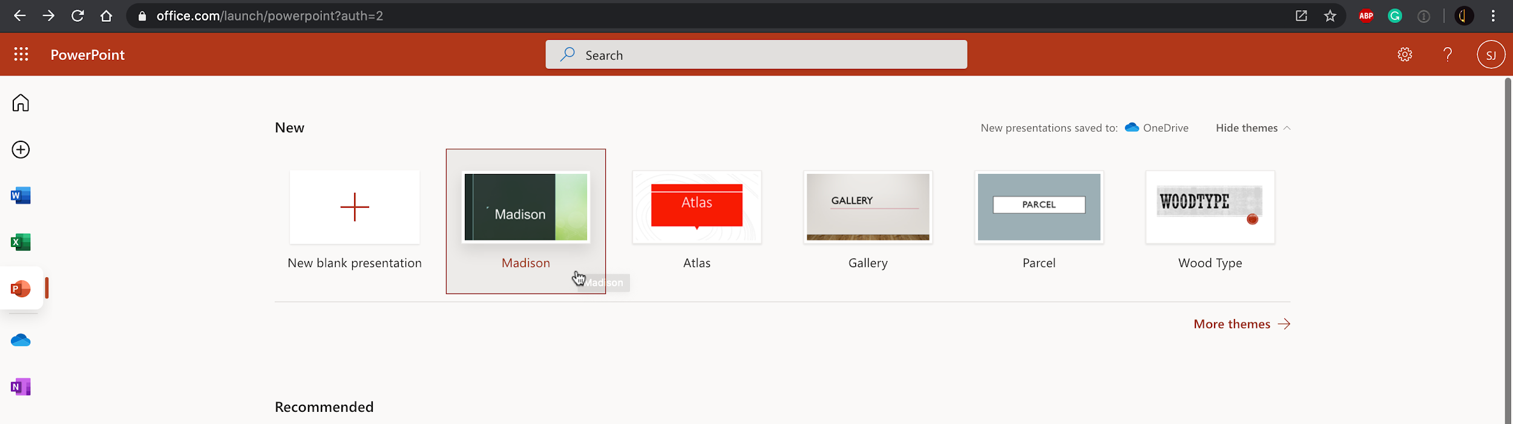

# Exercise 2: Add new slide and change slide layout and design

1. Click New Slide  
   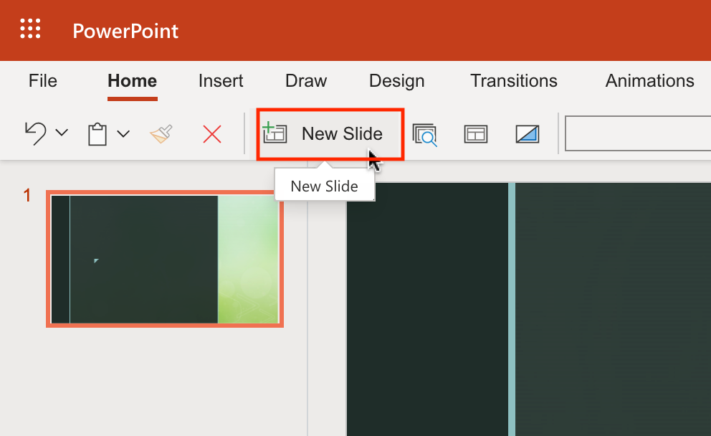
2. Select Picture with Caption type slide and click Add Slide.  
   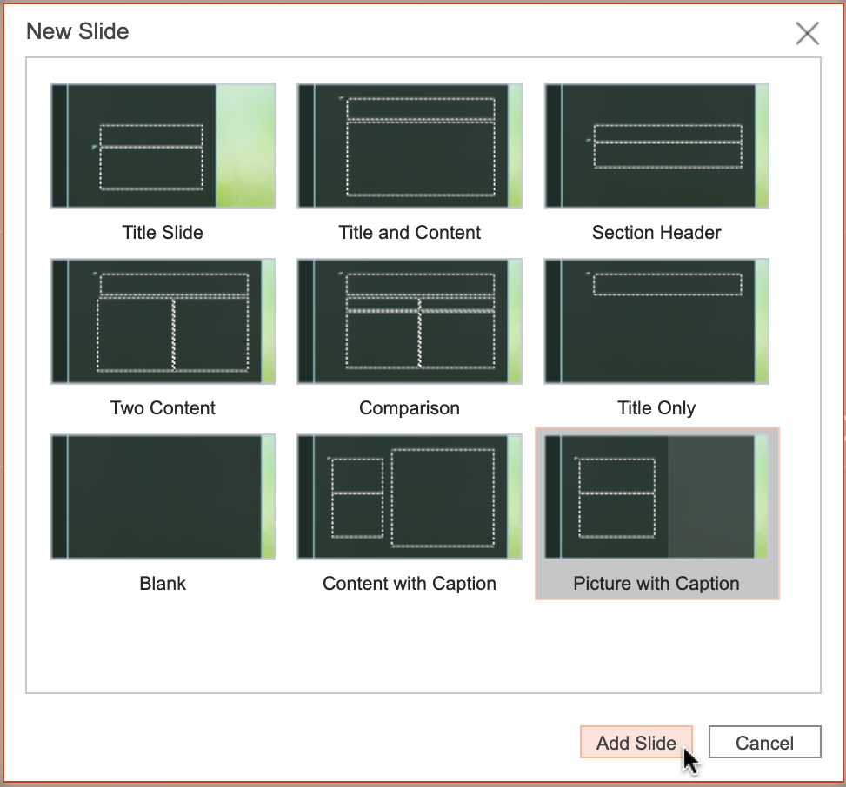
3. Go back to slide 1 and click Layout icon.  
   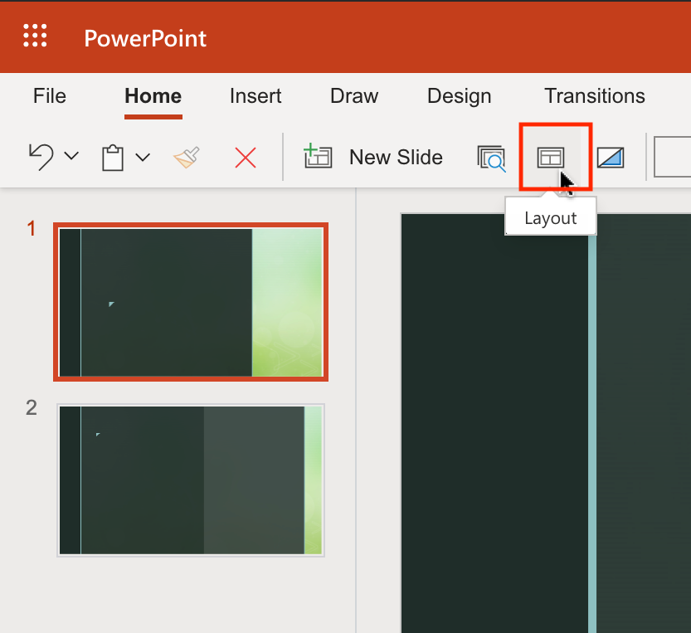
4. Select Title Only layout and click Change Layout.  
   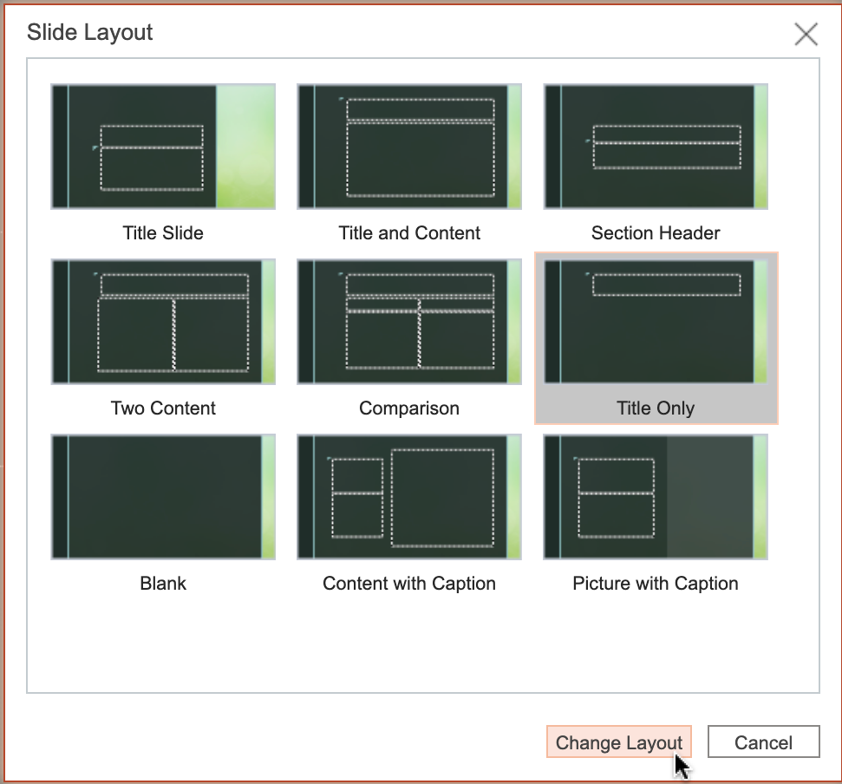
5. Select Designer. Select any design from the right Designer pane to change the design of slide 1.  
   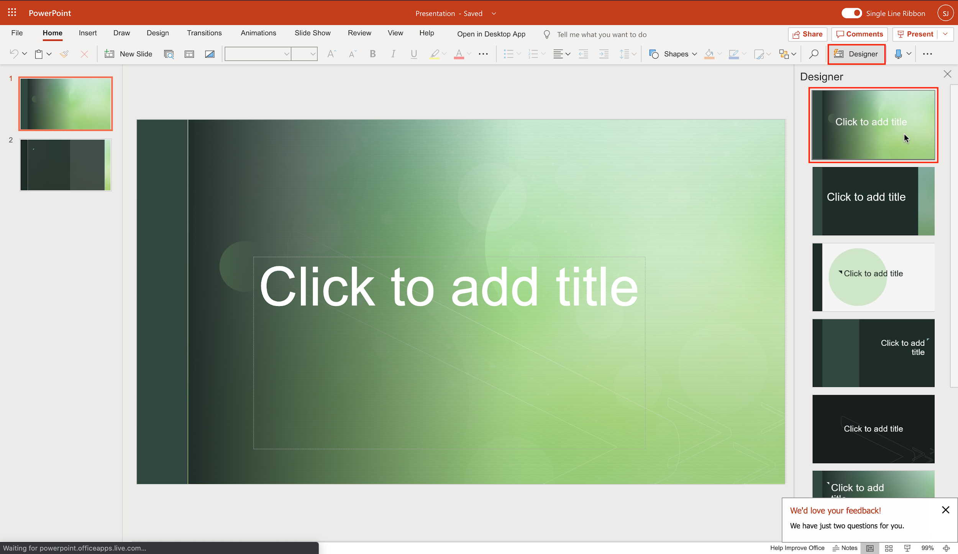

# Exercise 3: Add text, images, art, and videos

1. Switch to slide 1 if needed. Click on the textbox Click to add title and type "Basics of PowerPoint" as title.  
   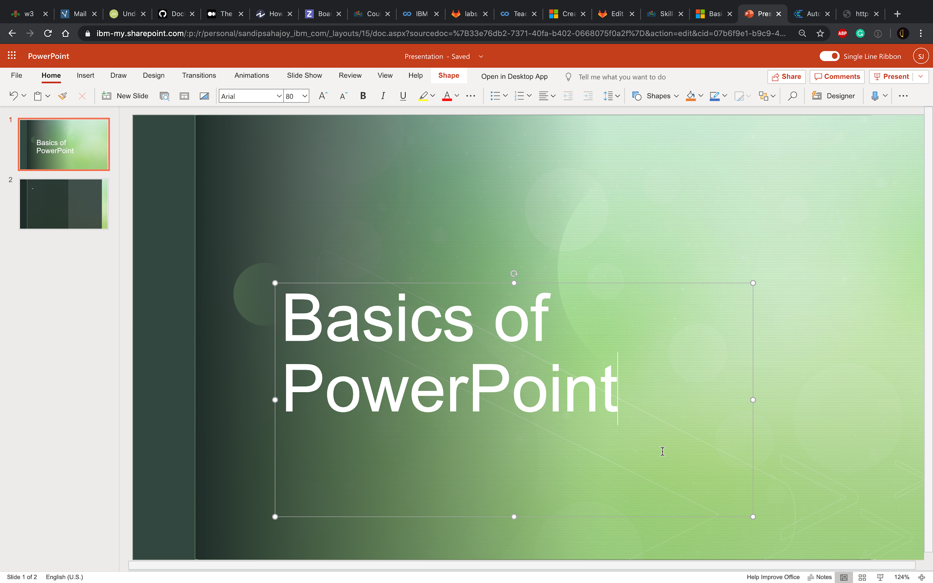
2. Switch to slide 2. Click on the textbox Click to add title and type "Objectives" as title.
3. Click on the textbox Click to add text and type:
   * Create presentations from scratch/ template​
   * Add new slide and change slide layout and design​
   * Add text, images, art, and videos
4. Select all text from second textbox and click Bulleted Library to select a bullet option.  
   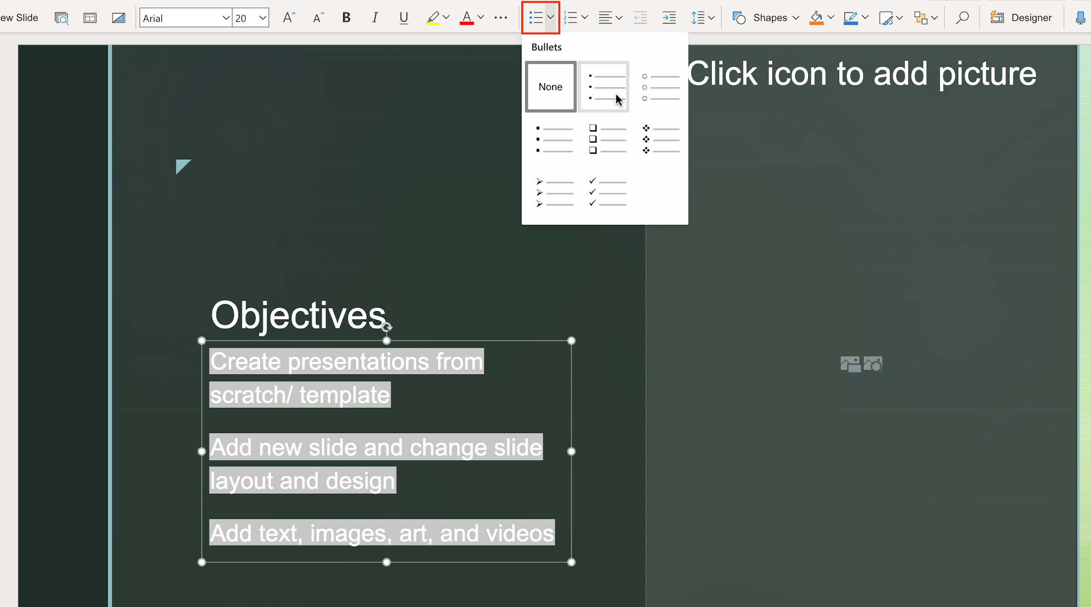
5. Now click the web search option like below from the right-hand section of the slide.  
   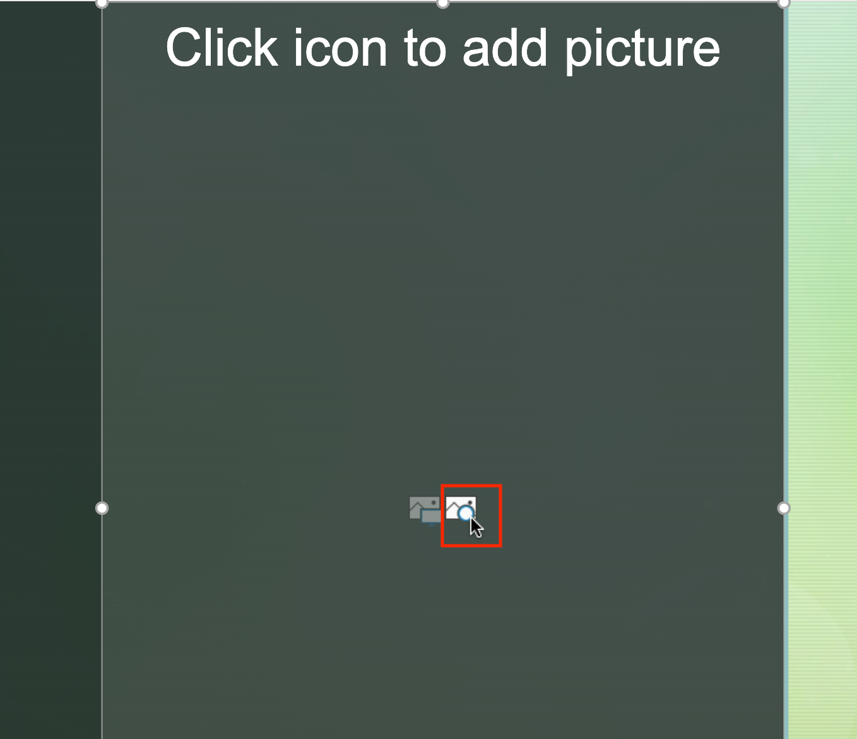
6. Type "presentation" and select an appropriate picture you like to add to your slide. Then click Insert.  
   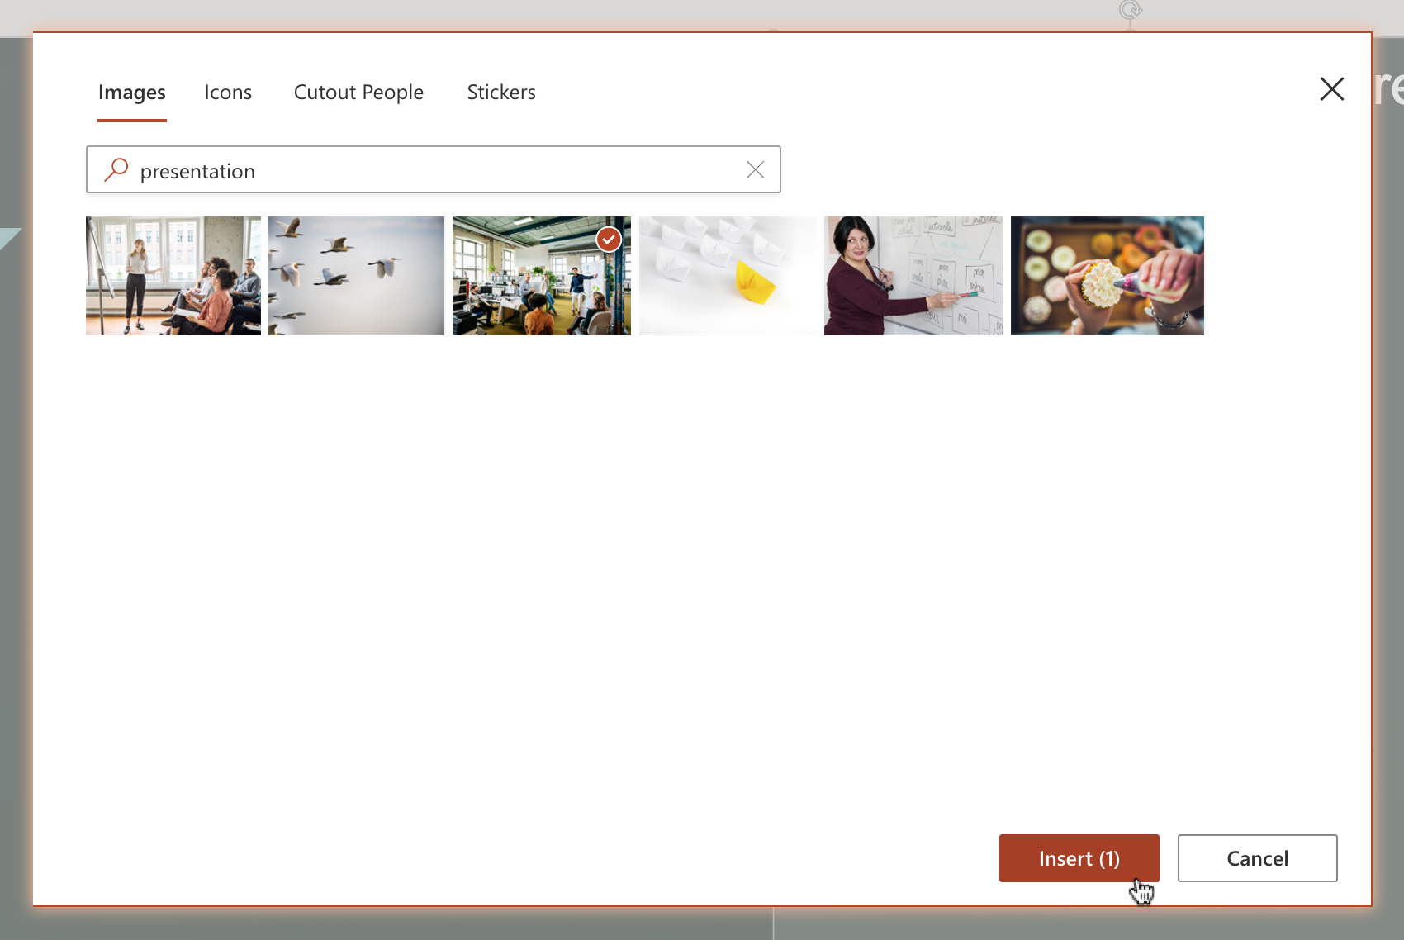
7. From the right Designer pane , select a design you like to visualize the inserted picture on the slide.  
   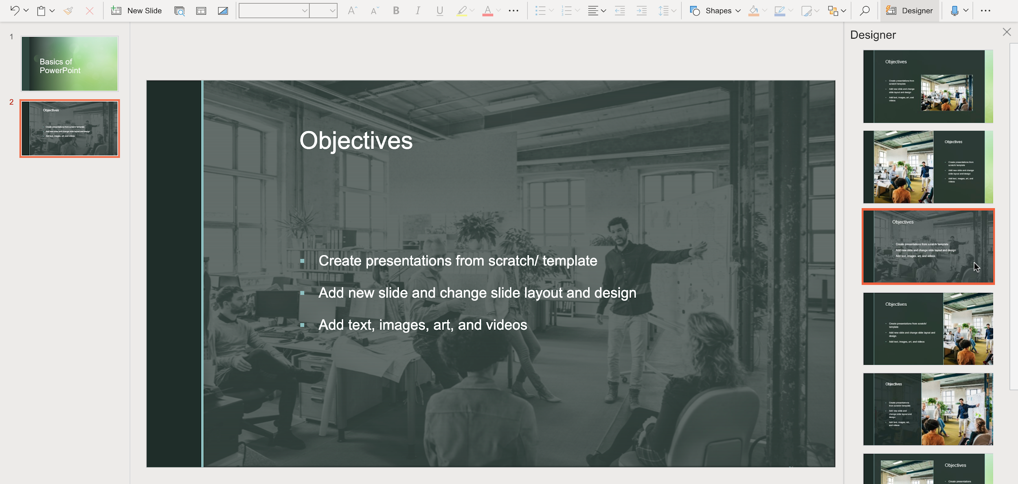

### Congratulations! You have completed this Lab.